COMPUTING IN INDUSTRIAL ENGINEERING LAB REPORT
Student Name
Institution
Course Name/Number
Due Date
Instructor Name

INTRODUCTION & BACKGROUND MATERIAL (TASK A)
Mobile phones are extensively used in today's rapidly advancing technology; the mobile phone user has become more demanding, resulting in rapid technological advancement. The mobile phone is no longer just an instrument for communication but also a fashion statement and "lifestyle" product with more functions. Mobile phones are designed to be stylish, colorful, and trendy besides offering high functionality. The mobile phone industry has become one of the most exciting and dynamic ones. . The mobile industry is full of challenges and tremendously exciting changes.
The mobile phone is one of the fast-growing industries in the market. The market for Mobile phones was $543 billion in 2007 and $501 billion in 2006 (Visiongain, 2008). It is estimated that by 2012, it will reach $777.7 billion (Cellular News, 2007). This proves how much this lucrative product has grown in these few years. Developing the product design involves using tools available to the engineer by which he can make simulations on how his new product will perform. An assessment of materials is equally important to have an economical solution that can withstand the forces of nature. Manufacture, quality control, and testing are also some of the other parts of this design process.
The mobile phone is a product whose generation speed is exceptionally fast. In the past decorating the mobile phone was a straightforward process since mobile phone decoration still depends on using its back cover, which can be replaced. Now mobile phone decoration involves in-depth customization in many steps such as hardware, cable, housing, and back cover. The purpose of this literature review in the form of a research proposal is to conduct a study on developing or designing a mobile phone in three basic stages: early planning, intermediate planning, and final planning.
Mobile phone product design and development involves processes and procedures that facilitate the disclosure of new products in the market. Mobile phone product development is a knowledge-based activity that makes it very difficult to manage. Mobile phones take different forms and designs and come in different sizes, shapes, textures, and colors. When developing a new product, it is critical to define the project scope. The essential products involved in the mobile product design are casing, screen, hardware, operating system, and accessories. Each product has its own set of materials that are designed to meet the customer's needs. Design and development of new mobile phones: the design and development process is a "complex and largely unpredictable process," consisting of four steps: concept generation, concept evaluation, concept selection, and detailed design. The product development process for mobile phones depends on the phase of the product lifecycle into which a project falls. Product development is a dynamic and complex task involving several stages, personnel, and organizations other than the organizations that produce the final product.
In the 2000 Scenario, the mobile phone market in India started to heat up, and competitive landscapes emerged. A new mobile phone was launched every few days, and retailers increased their efforts to maintain a low price point. The mobile phone industry had competition at every stage of product development, from research and production to marketing and after-sales services. Each competitor was trying to introduce a new mobile with a unique feature that would allow him to get a good share of the market. To produce a full-fledged mobile phone processor, companies work on the processors, screens, software, graphic chip, touch panel, memory chips, etc. It requires a lot of technology
The invention of the mobile telephone is undoubtedly one of the most important breakthroughs in communications. The mobile phone has become more than an exciting revolution in today's evolving world. Today, the mobile phone is essential to life, like any other vital aspect. It has made communication faster and more versatile. Due to escalating demand for cell phones or subscribers, the mobile phone market has been one of the fastest-growing sectors since the 1980s (Ye and Kankanhalli, 2018).
The Darma Tech Imitative company and other modern phone manufacturers design, manufacture, and distribute cellular phones in Middle-East countries (Xin, 2020). The adopted technical and entrepreneurial approach goes into detail on all design and development stages not just applicable in the current intended mobile phone product that the company offers but also in the future version with accommodating plans for expansion and other exciting prospects.
Mobile phone products are designed for users to access information through portable handsets. Since the first mobile phones, product design has played a critical role in its success. Before products are brought into the market, designers have already conducted research to determine the features and appearance preferred by consumers (Seymour Simon, 2002). Mobile phones also support other functionalities like media devices and web surfing. The first mobile phones were bulky with limited features due to the expensive technology at the time. As technology gets cheaper, more features are added to mobile phones, increasing their capability (Harte et al., 2017).

METHODOLOGY (TASK C)
Inputs for Mobile Phone product development are the resources needed to develop, manufacture, distribute and sell mobile phones. The resources can be people, knowledge, material, technology, or funds. But in this Project, the primary resources are the human personnel involved with the Project. They include; two production engineers, four industrial engineers, two process engineers, one Manufacturing/Plant Managers, three CAD/CAM specialists, two Material specialists, three Design Engineer, One Head of Engineering Design, One Marketing Team Leader, One Marketing Manager, and finally the Chief Executive Officer.
Using a life cycle approach to Mobile Product Development (MPD) helps ensure successful and timely delivery. There are inputs and outputs from the MBO, MBS inputs, technical environments supporting MPD, and other sources that must be extracted, refined, and analyzed. In practice, this information is obtained from The management of these inputs are effectively done with the help of activities required for each input.
The Mobile Phone Product Lifecycle consists of four phases - Product Concept Phase, Product Development Phase, Product Launch Phase, and Product Maintenance Phase. The Product Development Phase is further subdivided into Design Engineering Phase, Hardware Engineering Phase, Software Engineering Phase, Integration Testing Phase, Validation & Certification Phase, Mass Production Phase, and Delivery & Support Services Phase.
Similar to this project approach, Mobile Phone Development may be associated with several other phases or activities other than planning. These may include product idea generation, product concept development for different market segments, the product's beta launch, incremental additions to the product based on customer feedback, and other activities.
The methodology is based on the mobile product development stage, typically conducted when the mobile platform is ready. Mobile platforms in our context refer to the mobile hardware device and mobile operating systems. For example, in the case of mobile GSM handset, it will be a platform consisting of mobile hardware with various peripheral components like a Camera, Bluetooth with headset, internet access, GPS navigation with a compass, etc.
Mobile Phone Lifecycle comprises of ten sub-processes. The subprocess is product planning, specification, design, development, testing, implementation, hand-over, improvement & maintenance. The Outputs Outputs are the outcome of activities carried out in a process. The product is the desired result at the end of each cycle.
The product concept phase comprises three stages - Preliminary Analysis Phase, Market Evaluation Phase, and Preliminary Design Phase. The product design stage consists of six phases - Conceptual Design Phase, System Design Phase, Detailed Design Phase, Prototype Development Phase, Validation & Verification Phase, and Release & Manufacture Phase.
These processes are supported by various project management tools like Product Requirement Document (PRD), Product Specification, Document Control Procedure (DCP), Customer/User Documentation, Product Data Checklist, Process Flow Charts, Activity Dictionary, Task List, and others. In this document, all the information about the organization relevant to the product development process is specified. Specifications of different departments of the organization, procedures followed in those departments to ensure quality and successful development of the mobile phone are mentioned in this document.
Product Design Phase is the activity of designing the detail of the product. During this phase, the design team will need to involve the user of the end product to get more detailed requirements. Mobile Phone Product Development extends to the activities required to generate the final product. The final product must fit various customer needs and expectations, so their input is essential at the beginning of the Project. The methods used for generating the final product are to be developed based on information from customers.
Mobile phone products are becoming increasingly complex as a result of advancements in technology. To develop a product, a well-defined set of input activities is required to produce the products successfully. Unless the development process is properly planned and executed with adequate resources, there can be problems with cost, quality, and time. Managers must have a good understanding of the sequence of various activities involved in the development process. Defining activities, essential milestones, types of dependencies, relationships between project activities, resource requirements, and risks involved at every stage will provide overall guidance toward developing a successful product.
The Product Lifecycle Management (PLM) monitoring Tool helps combine planning, executing, tracking, and supporting the processes associated with product design, manufacture, and distribution. The DM Review module in IBM Rational Team Concert allows users to manage, track and manage changes in Product Data (PDM), software component data (SCD), product documents (PDD), along 3D models.
The Project has four main deliverables - Schedule, Cost, Requirements, and Risk Assessment Reports. These reports are to be submitted by the various project deliverable dates and the actual mobile phone prototype.

GANTT CHART
The following shows the reports and Gantt-chart visualization of the Mobile Product Development based on the highlighted methodology in chapter 2.
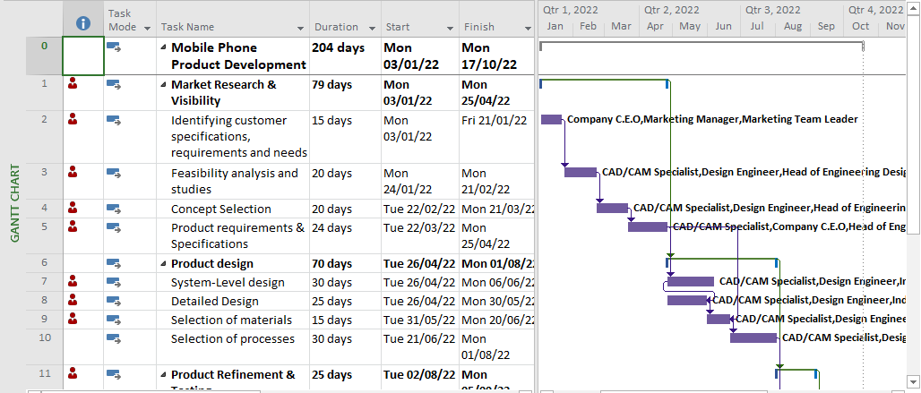
Figure showing the Gantt-chart representation of the Project with the activities.
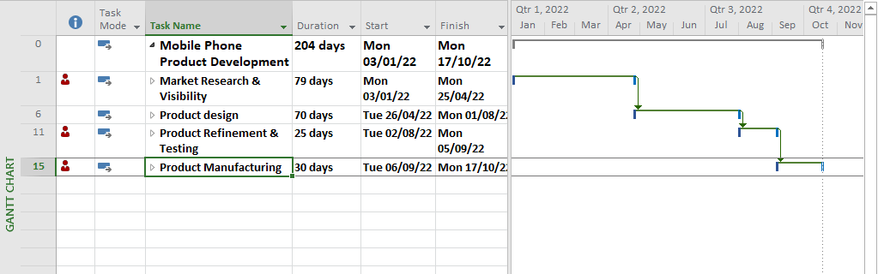
Figure showing the Gantt-chart representation of the Project with the Milestones.

Figure showing the Resource overview of the Mobile Phone development Project.

Figure showing the Work Status Resource Overview from Ms. Project.

Figure showing the percentage of completed work for the Employees in Darma Tech Initiative.

Figure with the Milestones overview in the Mobile Development Project.

RESULTS AND ANALYSIS QUESTIONS
The prototype is a modern Mobile Phone - This flagship Android smartphone from Darma Tech Initiative is set to unveil at the Mobile World Congress 2023 (January) and into commercial sale in April 2023. It features a Qualcomm Snapdragon 800 quad-core processor clocked at 2.26 GHz, a 5.2-inch 1080p display, 3 GB of RAM, 16 GB of internal storage, a 13-megapixel camera capable of recording 4K video, and a 3,000 mAh battery.

REFERENCES
Mirtalaie, M. A., Hussain, O. K., Chang, E., & Hussain, F. K. (2017). A decision support framework for identifying novel ideas in new product development from the cross-domain analysis. Information Systems, 69, 59-80.
Xing, Y. (2020). Global Value Chains and the Innovation of the Chinese Mobile Phone Industry. East Asian Policy, 12(01), 95-109.
Ye, H. J., & Kankanhalli, A. (2018). User service innovation on mobile phone platforms: Investigating impacts of lead users, toolkit support, and design autonomy. MIS Quarterly, 42(1), 165-188.

